Experiences gained from day to day work are used as a stimulus for learning and development and can be integrated into a busy general practice with the ultimate aim of improving the quality of care provided. Multi-professional practice based learning approach can have tremendous impact on the quality of care provided in general practice. It is recognised as being a vital part of the future development of primary care.

What Is it
A team-based approach to learning with PUNs and HENS. PUNS = patient unmet needs. HENS = health care profressional’s educational needs. It’s all about Group Directed Learning (GDL) based on practical problems in day to day practice with the ultimate goal of improving patient and practice care

The Four Main Principles of Practise Based Learning

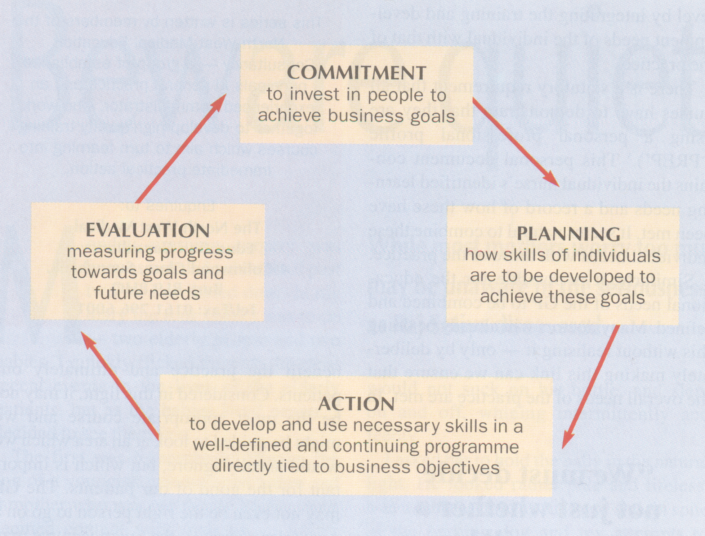

Commitment - i.e. support
Planning - Both clinical and practice organisation/business goals need to be set
- Identification of staff training and development needs
- Setting of training and development objectives at both organisation and
individual levels
Action - appropriate courses/events (either in/out of the practice)
Evaluation - Regular audit

Why Is It Necessary
Mainly because PGEA lectures address the concerns of consultants leading the lecture rather than that of the audience. People are interested in matters that they are interested in and subjects in which they have unanswered questions that they meet in day-to-day practice.

Barrie et al, BMJ 1997
Questioning behaviour in general practice; a pragmatic study
Showed that 2.4 clinical questions areise from each 10 consultations

The average GP has 30-40 consultations per day! Each question highlights a particular learning need, and provides a stimulus to find an answer. This is the highly practical basis of PBL (i.e. relevant and immediately applicable to practice and members interested in it). Adults have a desire towards Self-Directed learning. So why not use their experiences? In a group, the pooled experiences is a rich source of learning. The group will be guided by their specific learning needs generated by real problems. In so doing, they can then apply their new knowledge/skills to their immediate work.

Practice Based Learning enables the individual professional to refresh skills and knowledge and acquire the means to adapt or change roles.
Advantages of a PBL Approach (Sandars)
It is based in the working environment
Multi-professional working and teamwork is promoted
It is relevant to the real needs of the practice i.e. focus is on practical real issues
Individuals and practice develop at the same time
Suits individual learning styles
Quality of care of the practice population is improved

One Interesting observation
NHS Support Federation Research, 1998
Only 23% of GP’s had enough time to keep up to date with medicine/other recommended changes in practice.
The fact that the majority of GP’s might be unaware of a change in best practice is not a defence legally. A responsible body of opinion can be a group that is in the minority.

Practice Based Learning – helps you all keep up to date in a more effective, easier and relaxed manner. In addition, it has a real impact on patient care.

Guidelines for a PBL Approach
- Make it multi-professional where appropriate
- Map out the learning needs of the team and its individuals
- Draw up a Practice Development Plan
- Cover clinical, organisational and personal development areas
- All members of the team to actively participating in shared learning
- Use evidence-based guidelines where they exist (as opposed to expert opinion!)

Drawing up a Practice Development Plan
Plan to identify
- educational needs of those working in the practice
- health needs of the local population
- national priorities

